**Simulating Roulette: A Computation Statistics Project**

An Analysis by Clayton Moore, Kathryn Flanagan, and John Weng

Roulette is a game enjoyed by casino goers all across the world. Even though Roulette was original created by Frenchman Blaise Pascal in the 17th century, modern day American gamblers can find slight variations in the game. These variations involve different betting systems, different statistical odds, and usually less money in your wallet than when you arrived at the casino. In this report, we will be discussing the results and implications that certain betting strategies have in American Roulette, and decide if this game is profitable in the long run.

There are several assumptions that we make in order to have a consistent analysis throughout the project. First, we make sure that all simulations are done using an American Roulette wheel. This differs from other roulette wheels because it changes the odds of the game. Seen in Appendix A, an American Roulette wheel contains the numbers 1 through 36 with half of them given a color of red and half of them given a color of black. However, the American wheel also contains the numbers 0 and 00 (double zero), which are given a color of green. Another assumption we have is that we are only betting on one outcome, which is what color the number is going to be. Since the only outcomes can be red, black or green, and since we will only be betting on red or black, our probability of winning an individual bet is about 0.4737. It is not an even betting system because of the use of the 0 and 00 being green, which will be explained in greater detail later. In our analysis we have 5 players (Player A – Player E) who all implement different strategies. Each strategy will be introduced and reflected on in each individual section, but Player A’s play time is set while the other players will differ. This is because Players B through Player E will all stop betting if:

1. They reach a net winnings amount of W, where W is denoted as either $10, $20, or $30.
2. They do not have enough money to cover their bet.

Finally, each player is given $127 as a starting budget. Now that these assumptions are explained, we can compare the players’ strategies. For reference, all results can be found in Appendix 2.

Player A’s strategy consists of 127 bets, with each bet being $1. There is no variation in the amount of their bet, and they will always bet 127 times in one game, so their average play time per session is 127 with no standard deviation. The average winnings per session is -$6.53 so it is not a profitable strategy. The proportion of winnings, or the amount of times that a person will make money on the strategy, is 0.27403. Player A is not able to produce that many winnings per session, so this strategy is not the most productive. Let us now turn our attention to Player B, who might be able to produce more desirable results.

Player B’s strategy consists of starting at a bet of $1. When Player B wins, they increase their wager by $1. When Player B loses, they reset their bet down to $1. The average amount of bets in one game is relatively high (between 96 and 147 with a standard deviation of between 93 and 95) because it takes a long time either get to a new winnings of $W or to lose all of your money. The mean amount of winnings per game are -$14.67, with a standard deviation of $67.08. Player B wins more times than Player A, because their proportion of winnings is 0.74749. Even though you win a lot, you will lost a lot when you do lose, and that is why the winnings per session is so low.

Player C’s strategy is similar to Player B’s, but some variation in when to increase your bet and by how much. Like Player B, it starts with a bet of $1. When Player C loses, they increase their bet. They increase it by doubling their previous bet and then multiplying their new account. When Player C wins, the bet is reset to $1. After running the simulations, the mean amount of winnings per session are lower than Player B’s, with it ranging between -$5.39 to -$15.45 with a lower overall standard deviation. However, one adopting this strategy would play significantly less than Player B per game. This is a better strategy that Player B based on how much you “win” per game and how long each game lasts.

Player D uses a number sequence to determine how much to bet. One starts by having a list of numbers from 1 to 4. Player D will then sum the first and last numbers of the sequence to determine their bet, so the first bet that they will make is $5. If the player wins, then they delete the first and last number of the sequence and then originate their next bet off of the new first and last number. If the player loses, they add the sum to the end of the number sequence, and originate their next bet off of this new first and last number. When the list is empty, the sequence resets to a sequence with the numbers between 1 and 4. From the results of the simulation, we see that it has the lowest play time per session, with a range of about 10 to 20, depending on what W is set to. The amount of winnings per session will also stay relatively low, with a range of -$9.21 to -$16.90. The problem with scenario comes with a large standard deviation, so you can either win more money than the other strategies, or possible lose more money than the other strategies.

For Player E, our team decided to originate the betting system from the Fibonacci sequence. The Fibonacci sequence, first officially published in the 13th century by Fibonacci, is a number sequence that calculates its number based off how far one goes into the sequence. The formula for the Fibonacci sequence can be found in Appendix 3. The formula builds off the fact that the first and second number of the Fibonacci sequence (N=1 and N=2) are both equal to 1. From there, the sequence builds itself. How the betting works is that if one loses, Player E would increase N by 1. If the bet is won though, Player E would decrease N by 2. This strategy is seen by a favorable strategy at *Roulette Strategy*, a website that describes roulette strategies for gamblers. When the code and simulations were run, the strategy turned out not to be advantageous. The average winnings per session were between -$78.36 and -$119.42 depending on what W was set to, and the proportion of winnings were the lowest among all strategies besides when W was set to $10. The only advantage of this strategy came to how one could view the number of bets one could make in a game. Some people gamble to make money, but some people just enjoy playing the game and bet the bare minimum so they can stay on the table longer. Player E’s strategy would be a great strategy for the later of those players, since the mean play time per game can range from 1,480 to 2,251 depending on W. The reason why that number is so high relative to the other strategies is because it is very easy to gain your money back to the budget level, but it is very hard to make money over your budget level because you essentially have to win it a dollar at a time. This strategy favors people that want to stay on the table for a long time, but do not care if they lose a substantial amount of money.

All of the above strategies have their benefits and consequences, but in order to come to a final conclusion, we have to base a “best” strategy off of some metric. In order to do that, we will be looking at the possible winnings that someone will receive. Most people gamble so that they can win a lot of money, and that will be the way that we grade strategies. From looking at the means and standard deviations of winnings per session players B and D have the highest standard deviation, which means the profits in any game can different more from the mean. When W is increased to 30, the highest profiting player is Player D, who has a mean of -$16.90, and has a standard deviation of $81.46. Since this is the largest winnings that one could receive in any strategy for any level of W, our team would pick Player D as our optimal strategy.

The common trend with these strategies is that no matter what you set W to, you will not make money in the long run. Every strategy has a mean average winnings below zero. This is because of something called the house advantage. The house advantage is the reason that the 0 and 00 are on the board, because it gives the establishment that owns the game a chance to get money from every member playing no matter if they bet on red or black. This small chance tips the odds in the houses favor, resulting in the probability of winning a single bet in our case decreasing.

If there is an overall lesson to take from this analysis, it would be to not gamble. In the long run it is not profitable and you will just end up losing money. Our suggestion to readers of this analysis would be to invest in other industries or generate cash from a secondary source outside of purely gambling. However, if you would like to take a chance at gambling through playing American Roulette, our suggestion would be to adopt Player D’s strategy.

**WORKS CITED**

"House Edge in American and European Roulette - Roulette R Us. "House Edge in American and European Roulette - Roulette R Us. Web. 2 Dec. 2015.

"Red And Black Roulette Strategies." *Roulette Strategy*. Web. 26 Nov. 2015

"Fibonacci Sequence." *Math Is Fun*. Web. 28 Nov. 2015.

**APPENDIX**

APPENDIX 1: AMERICAN ROULETTE WHEEL

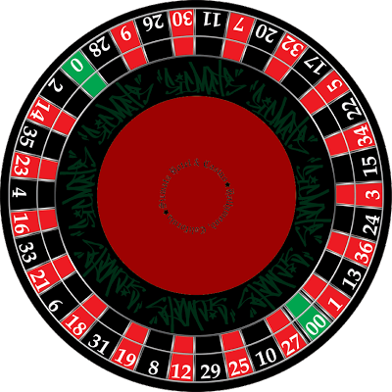

APPENDIX 2: TABLE OF RESULTS

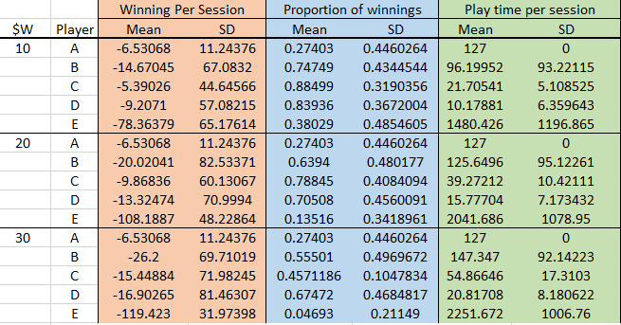

APPENDIX 3: FIBONACCI FORMULA

F_n = F_{n-1} + F_{n-2},\!\,

F_1 = 1,\; F_2 = 1